**Access to the Office of the Forum of X-Center Japan (FoXc-J)**

Access to FoXc-J Office

**Shinjyuku**

**To Meguro**

**Ueno**

**Shibuya**

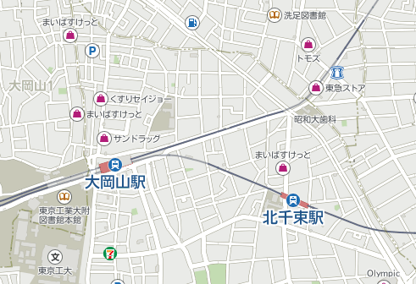

**Senzoku**

(4 stops)

**Shinagawa**

**Yokohama**

**Meguro**

**Haneda**

**Tokyo**

**Hamamatsucho**

**環状7号線**

**Ring road No. 7**

**.**

**地下鉄 目黒線**

**Subway Meguro line**

**Showa Univ. Dental hospital**

**Senzoku station**

**洗足駅**

**Tokyu supermarket**

**Tokyu Super market**

**Turn right**

**To Oimachi**

**To**

**Yokohama**

信号

Signal

**Oookayama station**

**Tokyo Institute**

**of Technology**

**FoXc-J**

**office**

.

**東急 大井町線**

**Tokyu Oimachi line**

**Kita-senzoku station**

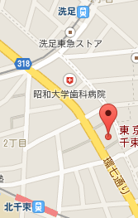

北千束五叉路

**Turn right**

**Signal**

**FoXc-J**

**Forum of X-Center Japan (FoXc-J)**

2-4-2 Kita-Senzoku, Ota-ku, Tokyo 145-0062 Japan  
Phone +81 3 6426-2577  
e-mail [watanabe.foxcj@rhythm.ocn.ne.jp](mailto:watanabe.foxcj@rhythm.ocn.ne.jp)  
          [watanabe.c.pqr@gmail.com](mailto:watanabe.c.pqr@gmail.com)

**5 minutes walk from Senzoku station in Meguro line**

(or Kita-senzoku station in Oimchi line)

**Two story yellow house alongside the Ring road No. 7**